Nada Abd_alftah Abd_alhamed

1. Install CentOS /RHEL

>>done

2. What is the difference between cat and more command?

* Cat >> return all content of the file
* More>> return content of the file page by page

3. What is the difference between rm and rmdir using man?

* rm: it use to remove files and directors when it contain files by using ( -r ) with it.
* rmdir:it use to remove directors when it not contain files

4. Create the following hierarchy under your home directory:

a. Remove dir11 in one-step. What did you notice? And how did you overcome that?

rmdir can’t remove it so I use rm -i

b. Then remove dir12 using rmdir –p command. State what happened to the hierarchy (Note: you are in your home directory).

This command delete dir12 and it’s parent dir1

c. The output of the command pwd was /home/user. Write the absolute and relative path for the file mycv

absolute:



Relative:

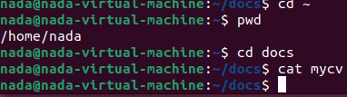

5. Copy the /etc/passwd file to your home directory making its name is mypasswd.



6. Rename this new file to be oldpasswd.

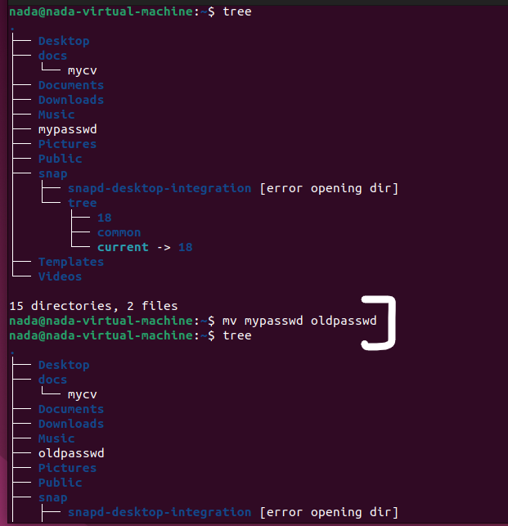

7. You are in /usr/bin, list four ways to go to your home directory



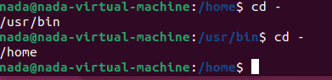

8. List Linux commands in /usr/bin that start with letter w

9. Display the first 4 lines of /etc/passwd

10. Display the last 7 lines of /etc/passwd

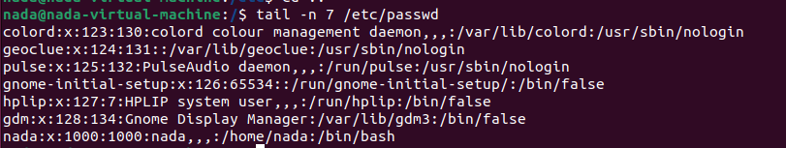

11. Display the man pages of passwd the command and the file sequentially in one command.



12. Display the man page of the passwd file.



13. Display a list of all the commands that contain the keyword passwd in their man page.

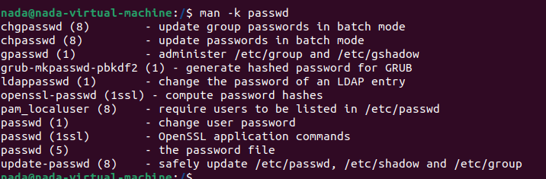

For exactly “passwd”.

